Timmins Diocesan Council of
The Catholic Women’s League of Canada
Spiritual Development Standing Committee

Catholic and Living It!
Care For Our Common Home

Directive #17 Pages: 3 February 22, 2022

To: Parish Presidents for Spiritual Development Chairpersons
From: Marie Black, Timmins Diocesan Spiritual Development Chairperson
Bcc: Annette Kelly, Diocesan President; Diocesan Officers; Emma Rose Rayburn,
Ontario Provincial Council Spiritual Development Chairperson; Fr. John
Lemire, Diocesan Spiritual Advisor; Anne Plaunt, Life Member Liaison, sub-
Committee member; Maggie Mowbray, sub-committee member

Hello, sisters in the League and Fr. John.
I sincerely hope all of you are doing well. So far, my family, including my 94 year old mother and 91 year old mother-in-law, has stayed safe and healthy these past two years. We definitely have been blessed.

I am sending you the following items, but you certainly do not have to send the whole directive to your members. Choose what you think would be of interest to them. You could also send the information at different times according to what comes first on the calendar. As well, it would be nice to invite others in the community and of different faiths to participate, if possible. I encourage you to also offer some of the information to your parish. If you have any questions, just let me know and I will try to help you.

Let us pray that our Lenten practices of almsgiving, prayer and fasting bring us closer to God – His healing gifts of love, mercy, forgiveness and reconciliation. By realizing that all is gift, let use God’s gifts in the service of Him and others.
May Our Lady of Good Counsel continue to guide us in all our League activities.

I wish you a fruitful Lent and God’s abundant blessings.
Sincerely,
Marie

- Winter 2022 issue of the League magazine:
- Page 2 – CATHOLIC and LIVING IT! , is the National theme. This prayer can be used at meetings, gatherings, etc.

- Page 6 -The Adventure of Walking Together, is the article written by Cathy Bouchard, National Chairperson of Spiritual Development. She points out that, “Pope Francis has gifted Catholics with a synod that compliments the new national theme, Catholic and Living It!
Pope Francis said, “Celebrating a Synod” means walking on the same road, together. He emphasized living out the three verbs that characterize a synod, “encounter, listen and discern”. According to Julian Paparella, special advisor to the Synod of Bishops in Rome, “‘Walking together’ is at the heart of what the church is all about , as the People of God on pilgrimage in the midst of the world. Synodality is a way of renewing the Church from her deepest roots.” The rest of the article gives more information on a synod and a website where you can find out more. Cathy concludes the article by saying as CWL members we live out our faith with our words and our actions.
Page 7 - Prayer for the Synod

- Indigenous Peoples and the Church: Walking Together Toward Healing and Reconciliation
We can pray for the success of the meeting in Rome the week of March 28. The Canadian Catholic Bishops, Assembly of First Nations, Métis National Council, and Inuit Tapiriit Kanatami will meet with Pope Francis and will have a final group audience on Friday, April 1.
In the communique received as an attachment to last Sunday’s church bulletin, the Canadian Conference of Catholic Bishops state that, “We remain committed to walking toward healing and reconciliation and very much look forward to the opportunity for Indigenous Elders, knowledge keepers, residential school survivors, and youth to meet with Pope Francis.” I know we all hope and pray that these meetings will be fruitful and achieve some healing and reconciliation from such pain.

- Help sustain the Catholic Faith in Canada by supporting Catholic Missions in Canada (CMIC).
CMIC is hosting a virtual fundraising gala, Tastes of Heaven, on Thursday, April 28, 2022 at 8pm. Registration is free and you can register with or without the $150 Wine Tasting Package. The wine tasting package includes – 2 X 750ml bottles of Waupoos Estates wine, 3 X 100g bars of Donini Chocolate and ingredients for a recipe demonstration by Christian Pritchard, executive chef of Aurora Importing & Distribution. The gala will take place at Waupoos Estates Winery in Prince Edward County. Everything will be delivered to your address while supplies last. The price includes shipping and handling. A charitable tax receipt will be issued if you choose the package. Perhaps you could get a group together to share the cost and enjoy the evening together. There is additional information online at www.cmic.info/taste-of-heaven. You can register for this event online as well or you can phone 416-934-3424 or 1-866-937-2642.

- World Day of Prayer (WDP), March 4, 2022, was written by the women of England, Wales and Northern Ireland. The theme is, “I Know the Plans I Have for You”, based on Jeremiah 29:1-14. Individuals or groups can decide which way they would like to access the service.
A) Go online to World Day of Prayer 2022 and you will find the service. Also on the website, is a list of resources you might be interested in downloading for free – posters, music, recipes,, hymn suggestions, a devotional video message, a Power Point service and more.
B) Type in “World Day of Prayer 2022 Virtual Service – YouTube”.
C) The local tv channels are YesTV on Saturday, March 5/22 at 8:00am and East Link TV on Friday March 4/22 at 8:30am and 4:00pm.

Don’t forget to advertise in your parish and community. Since it is already online, you can watch the service anytime at your convenience. It would also be a great opportunity to invite others in your parish and/community to join you. However, make sure you continue to follow the latest health guidelines in your area for COVID-19.

- LENT
Ash Wednesday is on March 2 and not too far away, so it is time to start thinking about Lent. Lent offers us the opportunity to grow in our relationship with God. The following is one possibility.
St. Paul Center: What to Do for Lent, is a free Lenten video series with Scott Hahn, plus Journey Through Lent, is a free pdf booklet with reflections on the daily Mass readings.
I sent the information to Fr, John to find out what he thought about the speaker and the series. He said it would be fine to send this resource to members if they are looking for something to guide them through Lent.
For those who are interested, go online to stpaulcenter.com, then click on Journey Through Lent where you will be able to register for free.
Ignore the top of the promo where it says, $5 flat rate shipping on domestic orders. There are books, etc. that you can buy if you want, but it is not required.

If you would like additional Lent resources for retreats, meditations, reflections, videos, explanations of Faith practices, etc., just let me know and I can send you the specific links. In fact, you could probably go online and check out Chalice Events, Bishop Barron’s Word on Fire, Pope Francis’ message for Lent 2022 and Catholic Family Lent, to name a few.
Learn MoreLearn MoreLearn More

BOOKS VIDEO AUDIO BIBLE STUDIES

What to Do for Lent

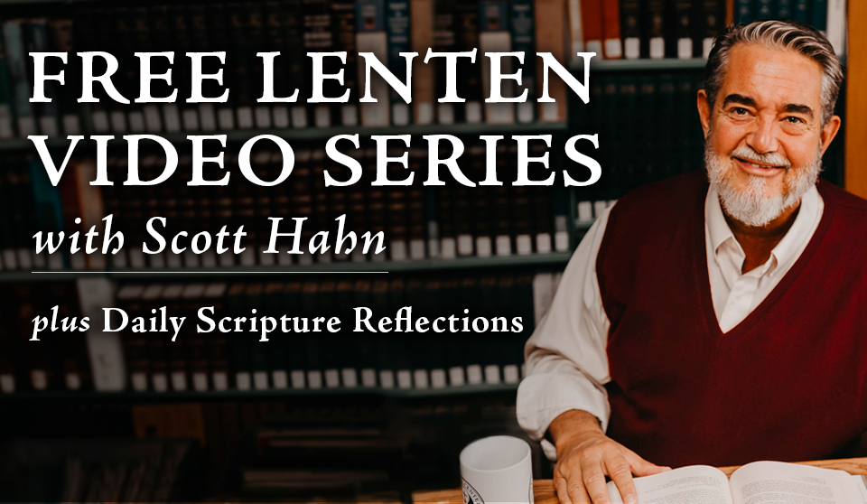

It's time to start thinking about Lenten devotions—Ash Wednesday is March 2!
This year, we're getting back to the roots of our faith. Join Scott Hahn for FREE Lenten streaming of faith-inspiring talks on Confession, prayer, the Eucharist, and knowing the Gospel. Don't miss this!

Sign Up Now

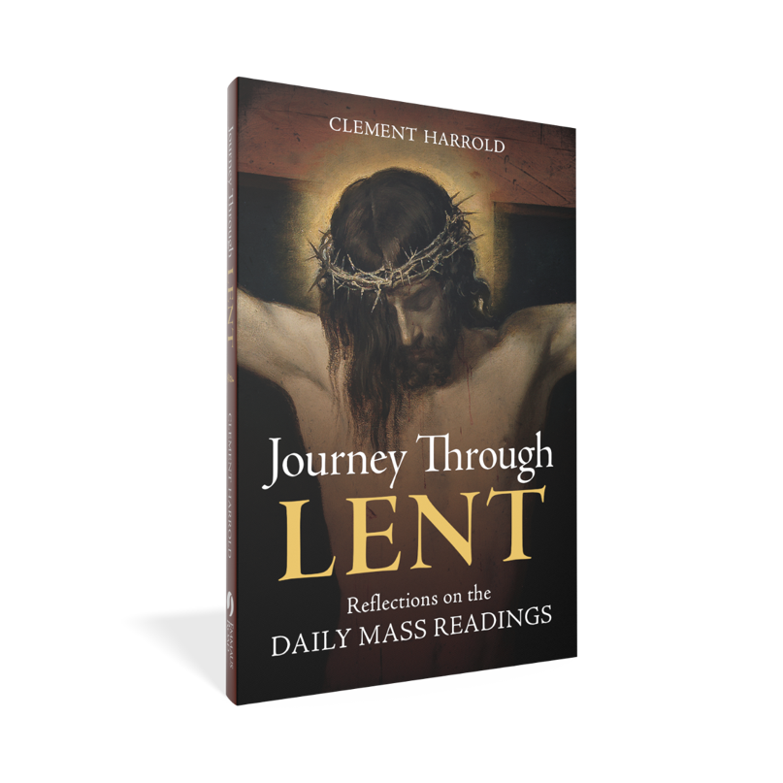
Everyone who registers for free Lenten streaming will also receive aFREE bonus PDF booklet of daily reflections on the Mass readings, “Journey Through Lent.”
That means you'll get free weekly talks by Scott Hahn AND daily reflections on the Scripture readings. Plus, get detailed outlines for each video and additional room for notes.

Learn More

"The Bible led me into the Church, and I love it deeply. But I could never find the riches hidden in its fields without the help of teachers like you, Dr. Hahn. Thank you."
—Susan D.

Sign Up Now

